7.2.19 Editors - 3D View - Header - Pose mode menus
Detailed Table of content 2
Pose Mode - Armature Object - Pose Menu 3
Bone Settings 3
Last Operator Collection Boolean Set 3
Draw Wire 3
Deform 4
Multiply Vertex Group with Envelope 4
Inherit Rotation 5
Inherit Scale 5
Show/Hide 5
Change Bone Layers 5
Last Operator Change Bone Layers 5
Layer 5
Change Armature Layers 5
Last Operator Change Armature Layers 6
Layer 6
Flip Quats 6
Flip Names 6
AutoName Top/Bottom 6
AutoName Front/Back 6
AutoName Left/Right 7
Constraints 7
Add (With Targets) 7
Copy Constraints to selected Bones 7
Clear Pose Constraints 8
Inverse Kinematics 8
Add IK to Bone 8
Last Operator Add IK to Bone 8
With Targets 8
Remove IK 8
Bone Groups 9
Assign to New Group 9
Assign to Group 9
Last operator Add Selected to Bone Group 9
Bone Group Index 9
Remove selected from Bone Groups 9
Remove Bone Group 9
Pose Library 9
Browse Poses 10
Last Operator Pose lib Browse Poses 10
Pose 10
Add Pose 10
Add New 10
Add New (Current Frame) 10
Replace Existing 10
Last Operator Pose Lib Add Pose 10
Frame 10
Pose Name 10
Rename Pose 10
Last Operator Pose Lib Rename Pose 11
New Pose Name 11
Pose 11
Remove Pose 11
Last Operator Pose Lib Remove Pose 11
Pose 11
Paste X-Flipped Pose 11
Paste Pose 11
Last Operator Paste Pose 11
Flipped on X-Axis 11
On Selected Only 11
Copy Pose 11
Apply 11
Apply Pose as Rest Pose 12
Apply Visual Transform to Pose 12
Clear Transform 12
All 12
Location 12
Rotation 12
Scale 12
Reset Unkeyed 12
Last Operator Clear User Transforms 12
Only Selected 12

Detailed Table of content

Pose Mode - Armature Object - Pose Menu

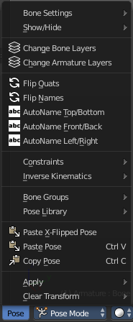
The Pose menu contains the tools to work with Armature objects in Pose mode. This means here you find all the tools that you need to pose and animate your armature.

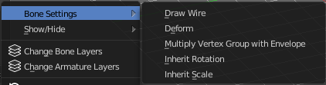
Bone Settings
Bone Settings is a menu with menu items to toggle special checkboxes in the Properties editor. But here you can do it for a selection too, and not just one object.

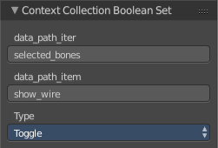
Last Operator Collection Boolean Set
Each of the menu items uses the same Last Operator. With different strings for the booleans.

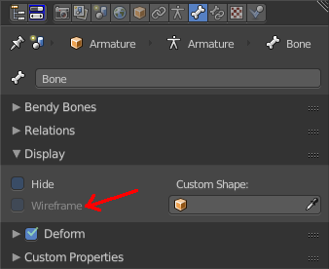
Draw Wire
Turns on or off the Wireframe checkbox, and so its functionality, in the Bones tab in the Display Panel Properties editor.
This checkbox requires to have a custom bone shape. It will not work at a normal bone shape. When you have a custom bone shape defined, then this custom bone object gets always displayed as Wireframe, regardless of viewport draw mode.
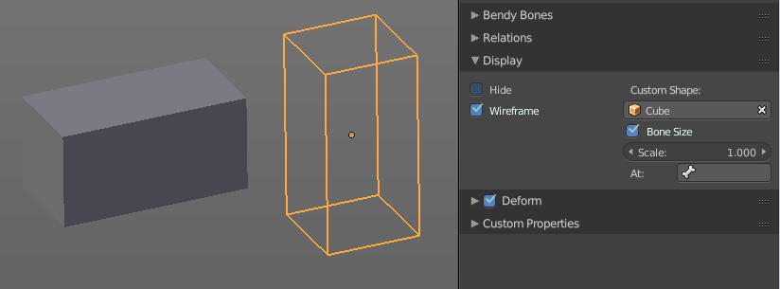

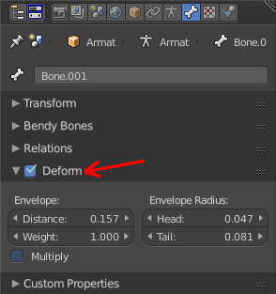
Deform
Turns on or off the Deform panel, and so its functionality, in the Bones tab in the Properties editor.
With Deform enabled the chosen bone deforms the connected mesh. The Deform panel also contains some Envelope settings.
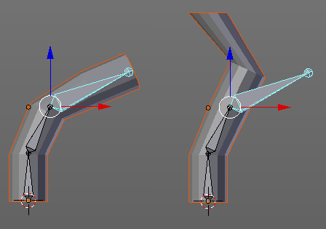

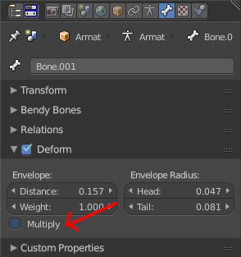
Multiply Vertex Group with Envelope
Turns on or off the Multiply checkbox in the Deform panel, and so its functionality, in the Bones tab in the Properties editor.
Multiply the effects of vertex group weights with envelope influence.

Inherit Rotation
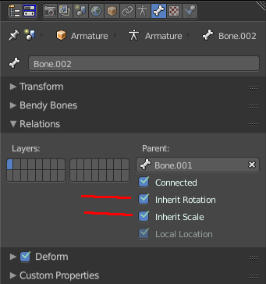
Turns on or off the Inherit Rotation checkbox in the Relations panel, and so its functionality, in the Bones tab in the Properties editor.
The bone inherits rotation from the parent bone.

Inherit Scale
Turns on or off the Inherit Scale checkbox in the Relations panel, and so its functionality, in the Bones tab in the Properties editor.
The bone inherits scale from the parent bone.

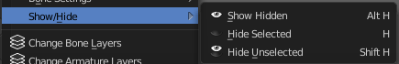
Show/Hide
Show/Hide is a menu. Here you can show or hide objects in the viewport. See chapter All Modes, all Object types - Show / Hide

Change Bone Layers
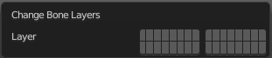
This menu item opens a popup where you can put single selected bone(s) onto another layer.
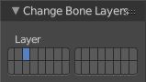

Last Operator Change Bone Layers

Layer
Here you can again put the selected bones onto another layer.

Change Armature Layers
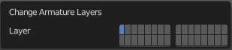
This menu item opens a popup where you can put the whole armature onto another layer.

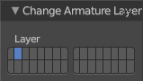
Last Operator Change Armature Layers

Layer
Here you can again put the armature onto another layer.

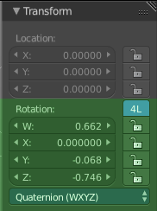
Flip Quats
This feature flips the quaternion rotation values of the currently selected bone(s). Positive values becomes negative, and negative values becomes positive.

Flip Names
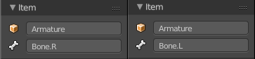
This tool requires to follow some name conventions. If there is a lower or upper case “L”, “R”, “left” or “right” with a separating dot in the bone name, then this tool renames the bones names to its counter part. Bone.L becomes Bone.R.
This tool is useful when you mirror parts of the armature, and don't want to rename all the bones one by one.

AutoName Top/Bottom
This tool automatically adds a suffix to all selected bones, based on their local position relative to the armature center.
Bones with a positive Z Coordinate will receive a .Top suffix. Bones with a negative Z coordinate will receive a .Bot suffix.

AutoName Front/Back
This tool automatically adds a suffix to all selected bones, based on their local position relative to the armature center.
Bones with a positive Y Coordinate will receive a .Fr suffix. Bones with a negative Y coordinate will receive a .Bk suffix.

AutoName Left/Right
This tool automatically adds a suffix to all selected bones, based on their local position relative to the armature center.
Bones with a positive X Coordinate will receive a .L suffix. Bones with a negative X coordinate will receive a .R suffix.

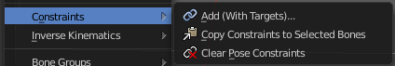
Constraints
Constraints is a menu that contains some tools around constraints.

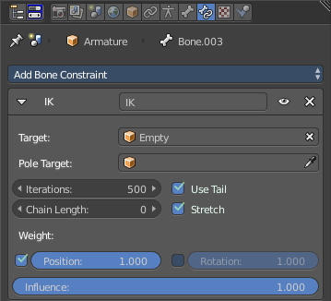
Add (With Targets)
Add (With Targets) calls the Constraints menu where you can choose the constraint that you want to add. When you add an IK constraints with just the bone selected, then it adds an empty as a handler too, and fills it in as a target.
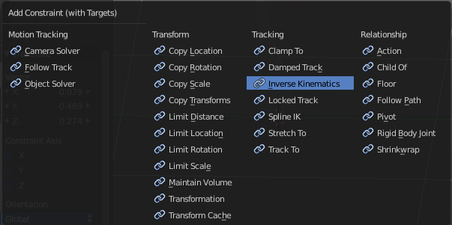
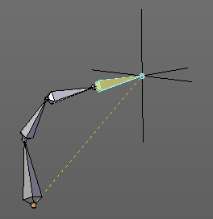

You can define a own target object too. The armature needs to be in pose mode. Let's create a cube or another primitive. Select it. Now hold down Shift, and click at the bone where you want to add the constraint too. Then choose Add (with Targets), and choose your constraint method. The cube will now be chosen as the target object.

Copy Constraints to selected Bones
Copies the constraints with all its settings to the selected bone.
Usage:
Select the bone where you want to copy the constraints to. Hold down shift, then select the bone that contains the constraints. Then perform the tool. The constraints will be copied.

Clear Pose Constraints
Removes all bone constraints modifiers from the bone.

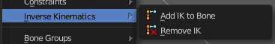
Inverse Kinematics
Inverse Kinematics is a menu with two isolated items from the whole bone constraints menu. The Inverse Kinematics. You could also add an Inverse Kinematics bone constraint by the Constraints / Add (With Targets) menu item from above. It is in the list. But this menu allows quick access without big search.

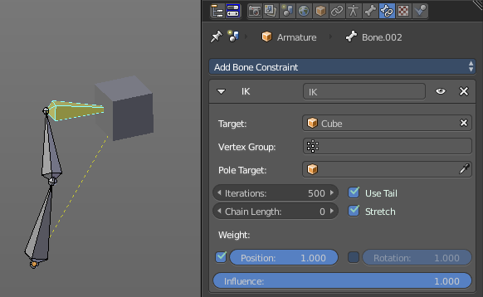
Add IK to Bone
Add IK to bone adds an IK bone constraint to the selected bone. When you add an IK constraints with just the bone selected, then it adds an empty as a handler too, and fills it in as a target.

You can define a own target object too. The armature needs to be in pose mode. Let's create a cube or another primitive. Select it. Now hold down Shift, and click at the bone where you want to add the constraint too. Then choose Add (with Targets), and choose your constraint method. The cube will now be chosen as the target object.

Last Operator Add IK to Bone

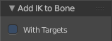
With Targets
Here you can define if you want to add the IK constraints with or without a target.

Remove IK
Removes all IK bone constraint(s) at the selected bone(s).

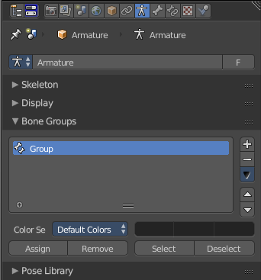
Bone Groups
Bone Groups is a menu to handle bone group functionality from within a menu in the 3D view. The bone groups themselves can be found in the Properties editor.

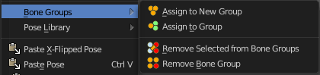

Assign to New Group
Assigns the selected bone(s) to a new group.

Assign to Group
Assigns the selected bone(s) to a existing group.

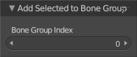
Last operator Add Selected to Bone Group
This last operator belongs to both tools. Assign to New Group, and Assign to Group.

Bone Group Index
Here you can adjust the Bone Group Index. An Index of 0 creates a new bone group. Higher values tries to assign the bone to existing bone groups instead.

Remove selected from Bone Groups
Removes the selected bone(s) from the assigned bone groups.

Remove Bone Group
Removes the currently active bone group.

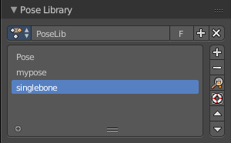
Pose Library
The content of this menu belongs to the Pose library. Which can be found in the Properties editor.
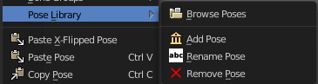

Browse Poses
With this feature you can browse through the available poses in the 3D view. While operation you will see informations in the header. It shows you what the current pose is, and how to navigate to the next or previous pose.
Note that you need to have the bones selected for which you want to display the poses. When in doubt, select all bones.

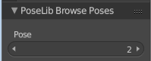
Last Operator Pose lib Browse Poses

Pose
Here you can scroll through the poses

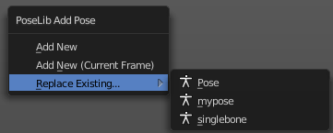
Add Pose
Here you can add a new pose for your armature to the pose library.
Note that you need to have the bones selected for which you want to add the pose. It just records the pose for the selected bones.
Calling the tool opens a popup where you can choose how you want to add the current pose.

Add New
Adds a new pose.

Add New (Current Frame)
Adds a new pose at the current frame. It does NOT record a keyframe.

Replace Existing
Here you can replace an existing pose.

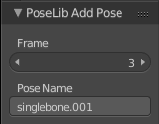
Last Operator Pose Lib Add Pose

Frame
The frame at which this pose should be created

Pose Name
Here you can rename the pose while creation.

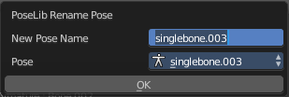
Rename Pose
Here you can rename a pose. It opens a popup menu where you can choose the pose to rename, and where you can rename it. One pose at a time.

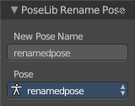
Last Operator Pose Lib Rename Pose

New Pose Name
Here you can enter the new pose name.

Pose
Here you can choose the pose that you want to rename.

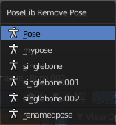
Remove Pose
Removes the currently active pose. The tool opens a popup where you can choose the pose to remove.

Last Operator Pose Lib Remove Pose

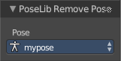
Pose
Here you can again choose which pose to remove.

Paste X-Flipped Pose
Pastes a formerly copied pose, and flips it around the X axis of the object. Local.

Paste Pose
Pastes a formerly copied pose.

Last Operator Paste Pose
This Last Operator belongs to both paste actions. Paste Pose and Paste X-Flipped Pose

Flipped on X-Axis
Flips the pasted pose around the X axis of the object.

On Selected Only
Pastes just to the currently selected bones. Not to the whole armature.

Copy Pose
Copies the current pose.

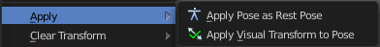
Apply
Apply is a menu with some Apply functionality.

Apply Pose as Rest Pose
You need a rest pose where you can reset the pose back to. With this tool you can set the current pose to be the new Rest pose.

Apply Visual Transform to Pose
Apply final constrained position of posed bones to their transform.

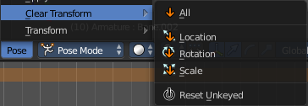
Clear Transform
Clear transform is a menu with some Clear functionality. You need to have the bones selected where you want to perform the operation. Unselected bones will not be calculated.

All
Resets location, rotation and scale back to the Rest pose.

Location
Resets location back to the Rest pose.

Rotation
Resets rotation back to the Rest pose.

Scale
Resets scale back to the Rest pose.

Reset Unkeyed
Resets the pose for the selected bones back to the state of the latest keyframe.

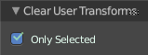
Last Operator Clear User Transforms

Only Selected
Clear User transform for selected armature part, or for the whole armature.

